30.58: a) If 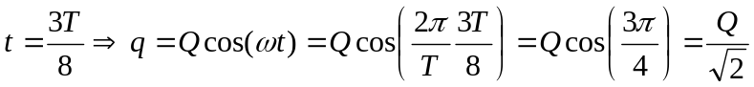
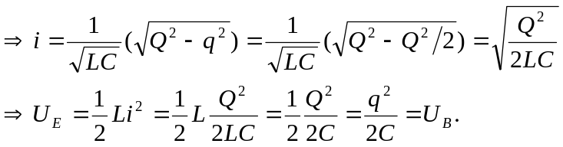
b) The two energies are next equal when 